AS01 – Create Asset Master

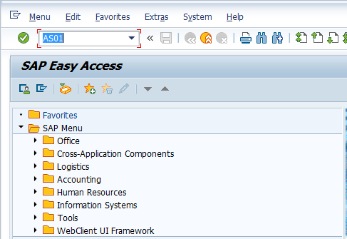

- Input AS01 in Transaction Box and press Enter key

Create Asset Initial Screen.

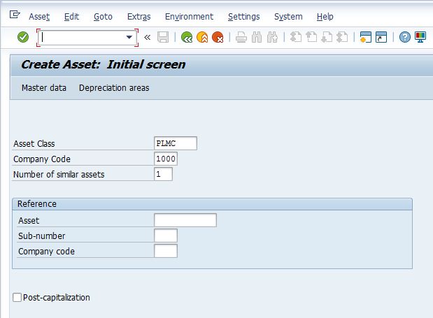

- Asset Class: Select relevant asset class with the help of F4 key
- Company code: Input relevant company code
- Number of similar assets: Input number of similar assets based on your requirement
Press Enter key

Create Asset Master Data Screen.

General Tab

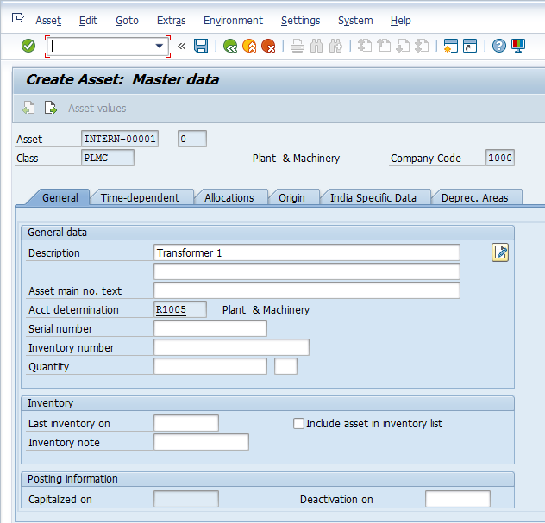

- Description: Input required/relevant asset description
Click on Time-dependent tab

Create Asset Master Data Screen.

Time-dependent Tab

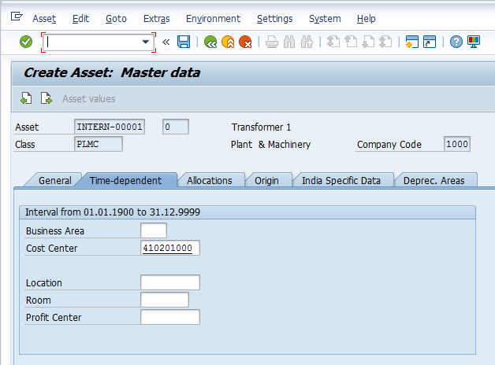

- Cost Center: Select relevant cost center with the help of F4 key
Select India Specific Data tab

Create Asset Master Data Screen.

India Specific Data Tab

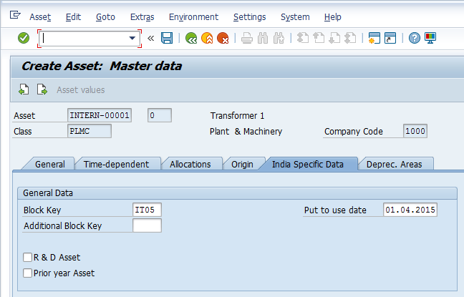

- Block Key: Select relevant block key with the help of F4 key
- Put to use date: Input or Select relevant put to use date with the help of F4 key
Select Deprec. Areas tab

Create Asset Master Data Screen.

Deprec. Areas Tab

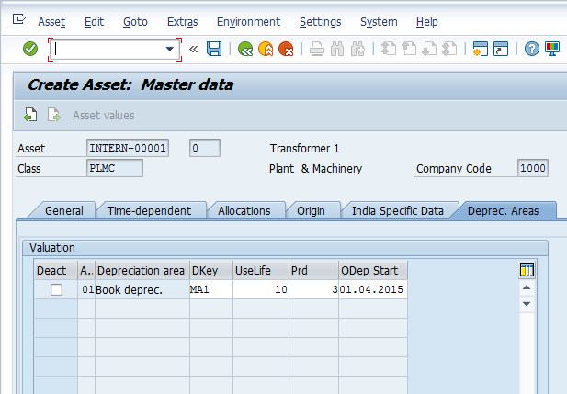

- UseLife: Input useful life of the asset
- Prd: Input or select period
- 0Dep Start: Input depreciation start date or select the same with the help of F4 key
Click on Save icon or press Ctrl+S keys to save the data

Create Asset Depreciation Area Book Depreciation Screen.

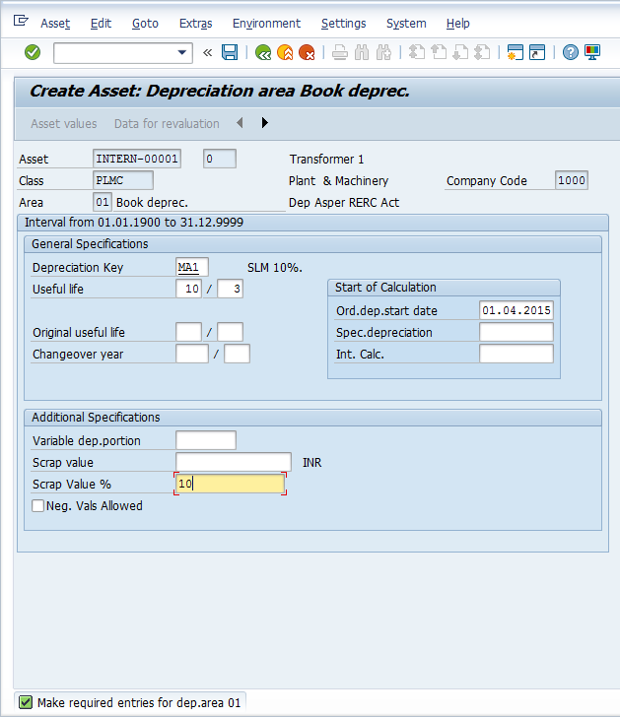

- Scrap Value %: Input scrap value percentage of the asset
Click on Save icon or press Ctrl+S keys to save the data

The asset is successfully created message appears at bottom of the screen

Manual End

